**TASK_4 – EXCEPTION HANDLING PROGRAMS**

**PROGRAM 1 – ARITHMETIC EXCEPTION**

**public** **class** Arithmetic_Exception {

**public** **static** **void** main(String[] args)

{

System.***out***.println("Enter two numbers");

Scanner sc = **new** Scanner(System.***in***);

**int** a = sc.nextInt();

**int** b = sc.nextInt();

**int** d;

**try**

{

d = a/b; // throws arithmetic exception when number divisible by 0 is invalid

System.***out***.println("The division value is "+ d);

} **catch** (ArithmeticException e)

{

System.***out***.println("Number divisible by 0 is not valid");

}

**finally**

{

System.***out***.println("End of the program");

}

}

}

**OUTPUT 1 :**

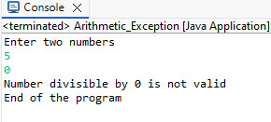

**OUTPUT 2:**

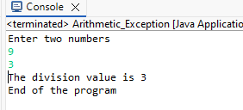

**PROGRAM 2.a– ArrayIndexOutOfBound Exception**

**public** **class** ArrayIndexOutOfBound {

**public** **static** **void** main(String[] args)

{

System.***out***.println("Start of the Program");

**int**[] a= {30,60,90,120,150};

System.***out***.println("Enter the index value");

Scanner sc= **new** Scanner(System.***in***);

**int** i = sc.nextInt(); //for index

**try**

{

System.***out***.println(a[i]);

}

**catch** (ArrayIndexOutOfBoundsException e)

{

System.***out***.println("Sorry you entered a wrong index");

}

**finally**

{

System.***out***.println("End of the program");

}

}

}

**Output 1:**

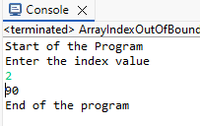

**Output 2:**

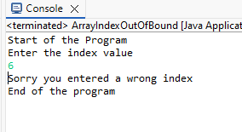

**PROGRAM 2.b– SringIndexOutOfBound Exception**

**public** **class** String_IndexOutOfBounds {

**public** **static** **void** main(String[] args)

{

System.***out***.println("Start of the Program");

System.***out***.println("Enter the String");

Scanner sc= **new** Scanner(System.***in***);

String str = sc.nextLine();

System.***out***.println("Enter the Index value");

**int** i = sc.nextInt();

**try**

{

System.***out***.println(str.charAt(i));

}

**catch** (StringIndexOutOfBoundsException e)

{

System.***out***.println("Sorry!! there is no character with the index in this string");

}

**finally**

{

System.***out***.println("End of the program");

}

}

}

**Output 1:**

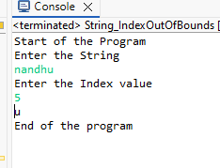

**Output 2:**

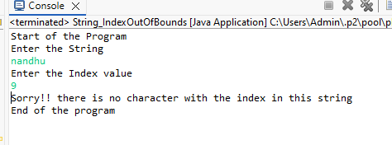

**PROGRAM 3 – ARITHMETIC EXCEPTION**

**Exception class:**

**public** **class** InvalidAgeException **extends** Exception

{

**public** InvalidAgeException()

{

**super**(); //Default constructor

}

}

**Main Method class:**

**public** **class** ValidAge {

**public** **void** ValidateAge() **throws** InvalidAgeException

{

System.***out***.println("Enter the age of the person");

Scanner sc = **new** Scanner(System.***in***);

**int** age = sc.nextInt();

**if** (age > 18)

{

System.***out***.println("Person is Eligible");

}

**else**

{

**throw** **new** InvalidAgeException();

}

}

**public** **static** **void** main(String[] args)

{

ValidAge obj = **new** ValidAge();

**try**

{

obj.ValidateAge();

}

**catch**(InvalidAgeException e)

{

e.printStackTrace();

System.***out***.println("Invalid Age entered");

}

**finally**

{

System.***out***.println("End of the Program");

}

}

}

**OUTPUT:**

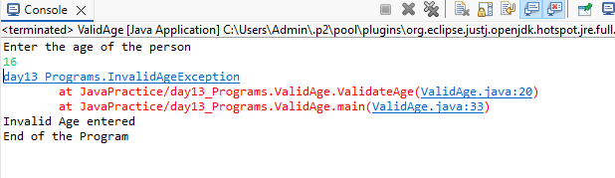

**PROGRAM 4 – FILE NOT FOUND EXCEPTION**

**import** java.io.FileNotFoundException;

**import** java.io.FileReader;

**import** java.io.IOException;

**public** **class** FileNotFound_Exception {

**public** **static** **void** main(String[] args)

{

**try**

{

FileReader File = **new** FileReader("D:\\GUVI\\Java program\\exp\\prog.txt");

}

**catch** (FileNotFoundException e)

{

e.printStackTrace();

System.***out***.println("Error Message : File is not found in the specified path");

}

}

}

**OUTPUT:**

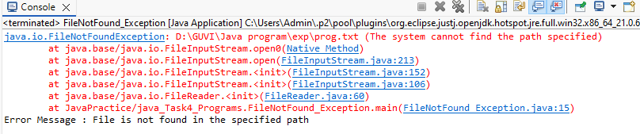

**PROGRAM 5– FILE NOT FOUND EXCEPTION**

**public** **static** **void** main(String[] args)

{

ArrayList<String> Countries = **new** ArrayList<>();

Countries.add("INDIA");

Countries.add("USA");

Countries.add("Australia");

Countries.add("Russia");

Countries.add("Canada");

Countries.add("Japan");

Countries.add("China");

System.***out***.println(Countries);

System.***out***.println("Removing String elements from ArrayList");

Countries.remove("INDIA");

Countries.remove("USA");

Countries.remove("Australia");

Countries.remove("Russia");

Countries.remove("Canada");

System.***out***.println(Countries);

//Countries.remove("Japan");

//Countries.remove("China");

}

**OUTPUT 1:**

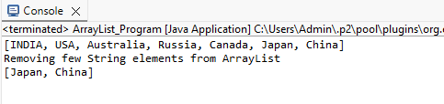

**OUTPUT 2:**

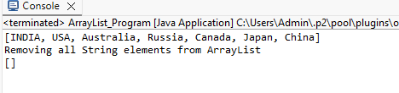

**PROGRAM 6 – CREATE TREEMAP AND PRINT**

**public** **class** Employee {

**public** **static** **void** main(String[] args)

{

System.***out***.println("TreeMap Program");

TreeMap<Integer, String> Emp = **new** TreeMap<>();

Emp.put(01, "Aarthi");

Emp.put(06, "Tarun");

Emp.put(03, "Beryl");

Emp.put(05, "Savitha");

Emp.put(02, "Anu");

Emp.put(04, "Mohan");

System.***out***.println("Employee names in alphabetical order:");

**for** (Map.Entry<Integer, String> entry : Emp.entrySet())

{

System.***out***.println(entry.getValue()); //Printing only values

}

}

}

**OUTPUT:**

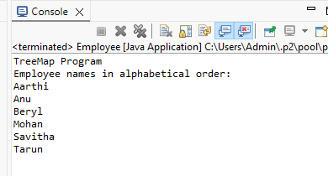

**PROGRAM 7 – CONVERT LIST TO ARRAY**

**public** **class** List_To_Array

{

**public** **static** **void** main(String[] args)

{

System.***out***.println("Program to convert List to Array");

System.***out***.println();

List <String> lst = **new** ArrayList<>();

lst.add("BMW");

lst.add("Ford");

lst.add("Audi");

lst.add("Benz");

lst.add("Toyota");

lst.add("Ferrari");

Object[] arr = lst.toArray();

System.***out***.println("Array values are");

System.***out***.println(Arrays.*toString*(arr));

}

}

**OUTPUT:**

